Place Title Here

First A. Author[1], Second B. Author[2], Third C. Author[3] and Fourth D. Author[4]

Group # 01, ASEN 2001, 08/24/2009

Write abstract here. Write abstract here. Write abstract here. Write abstract here. Write abstract here. Write abstract here. Write abstract here. Write abstract here. Write abstract here. Write abstract here. Write abstract here. Write abstract here. Write abstract here. Write abstract here.

# Nomenclature

*A* = amplitude of oscillation

*a* = cylinder diameter

*Cp*= pressure coefficient

*Cx* = force coefficient in the *x* direction

*Cy* = force coefficient in the *y* direction

c = chord

d*t* = time step

*Fx* = *X* component of the resultant pressure force acting on the vehicle

*Fy* = *Y* component of the resultant pressure force acting on the vehicle

*f, g* = generic functions

*h* = height

*i* = time index during navigation

*j* = waypoint index

*K* = trailing-edge (TE) nondimensional angular deflection rate

# Introduction

W

RITE introduction here. Write introduction here. Write introduction here. Write introduction here. Write introduction here. Write introduction here. Write introduction here. Write introduction here. Write introduction here. Write introduction here. Write introduction here. Write introduction here. Write introduction here. Write introduction here. Write introduction here.

Write introduction here. Write introduction here. Write introduction here. Write introduction here. Write introduction here. Write introduction here. Write introduction here. Write introduction here. Write introduction here. Write introduction here. Write introduction here. Write introduction here.

# First Body Paragraph

Write first body paragraph here. Write first body paragraph here. Write first body paragraph here. Write first body paragraph here. Write first body paragraph here. Write first body paragraph here. Write first body paragraph here. Write first body paragraph here. Write first body paragraph here. Write first body paragraph here. Write first body paragraph here. Write first body paragraph here. Write first body paragraph here. Write first body paragraph here.

Write first body paragraph here. Write first body paragraph here. Write first body paragraph here. Write first body paragraph here. Write first body paragraph here. Write first body paragraph here. Write first body paragraph here. Write first body paragraph here. Write first body paragraph here. Write first body paragraph here. Write first body paragraph here. Write first body paragraph here. Write first body paragraph here. Write first body paragraph here.

# Second Body Paragraph

Write second body paragraph here. Write second body paragraph here. Write second body paragraph here. Write second body paragraph here. Write second body paragraph here. Write second body paragraph here. Write second body paragraph here. Write second body paragraph here. Write second body paragraph here. Write second body paragraph here. Write second body paragraph here. Write second body paragraph here. Write second body paragraph here. Write second body paragraph here.

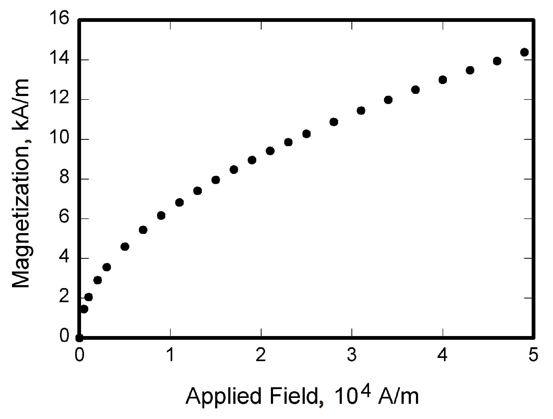

Figure 1. Place Caption Here.

Write second body paragraph here. Write second body paragraph here. Write second body paragraph here. Write second body paragraph here. Write second body paragraph here. Write second body paragraph here. Write second body paragraph here. Write second body paragraph here. Write second body paragraph here. Write second body paragraph here.

## Second Body First Subsection

Write second body first subsection paragraph here. Write second body first subsection paragraph here. Write second body first subsection paragraph here. Write second body first subsection paragraph here. Write second body first subsection paragraph here. Write second body first subsection paragraph here.

## Second Body Second Subsection

Write second body second subsection paragraph here. Write second body second subsection paragraph here. Write second body second subsection paragraph here. Write second body second subsection paragraph here. Write second body second subsection paragraph here. Write second body second subsection paragraph here. Write second body second subsection paragraph here.

# Conclusion

Write conclusions here. Write conclusions here. Write conclusions here. Write conclusions here. Write conclusions here. Write conclusions here. Write conclusions here. Write conclusions here. Write conclusions here. Write conclusions here.

# Appendix

Insert any needed appendices here.

# Acknowledgments

If you need to acknowledge someone’s help, you can do so here or delete this section if not needed.

# References

1Vatistas, G. H., Lin, S., and Kwok, C. K., “Reverse Flow Radius in Vortex Chambers,” *AIAA Journal*, Vol. 24, No. 11, 1986, pp. 1872, 1873.

2Dornheim, M. A., “Planetary Flight Surge Faces Budget Realities,” *Aviation Week and Space Technology*, Vol. 145, No. 24, 9 Dec. 1996, pp. 44-46.

3Terster, W., “NASA Considers Switch to Delta 2,” *Space News*, Vol. 8, No. 2, 13-19 Jan. 1997, pp., 1, 18.

4Peyret, R., and Taylor, T. D., *Computational Methods in Fluid Flow*, 2nd ed., Springer-Verlag, New York, 1983, Chaps. 7, 14.

5Oates, G. C. (ed.), *Aerothermodynamics of Gas Turbine and Rocket Propulsion*, AIAA Education Series, AIAA, New York, 1984, pp. 19, 136.

6Volpe, R., “Techniques for Collision Prevention, Impact Stability, and Force Control by Space Manipulators,” *Teleoperation and Robotics in Space*, edited by S. B. Skaar and C. F. Ruoff, Progress in Astronautics and Aeronautics, AIAA, Washington, DC, 1994, pp. 175-212.

7Thompson, C. M., “Spacecraft Thermal Control, Design, and Operation,” *AIAA Guidance, Navigation, and Control Conference*, CP849, Vol. 1, AIAA, Washington, DC, 1989, pp. 103-115

1. Insert Student ID for first author.
2. Insert Student ID for second author.
3. Insert Student ID for third author.
4. Insert Student ID for fourth author (etc).